Name _______________________________________
AP Physics 1 Ch 19 HW Problems 83 & 84 Redux
83. Use the diagram to rank the brightness of each resistor (use R = 30 Ω) when…
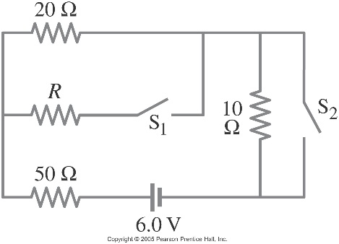 e) Which set-up has overall bright/dimmest bulbs?
- Both switches are closed:

- Both switches are open:

- S1 is open, but S2 is closed:

- S2 is closed, but S1 is open:

84. Use the diagram to determine how each resistor is wired with each other resistor – Series or Parallel?

